
PROBLEM STATEMENT

Day 31 : Always_case
Day 32 : Always_case2
Day 33 : Always_casez
Day 34 : Always_nolatches
Day 35 : Conditional
Day 36 : Reduction
Day 37: gates100
Day 38 : vector100r
Day 39 : popcount255
Day 40: Adder100i

DAY:31 Always_case
Problem Statement:
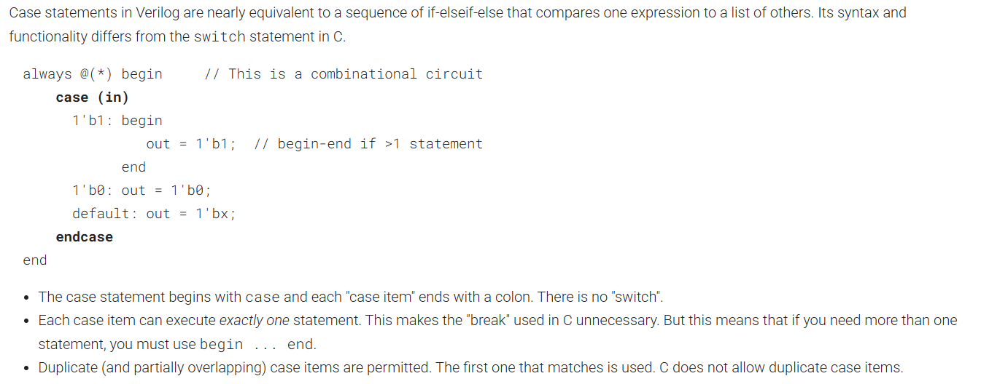
Module Declaration:
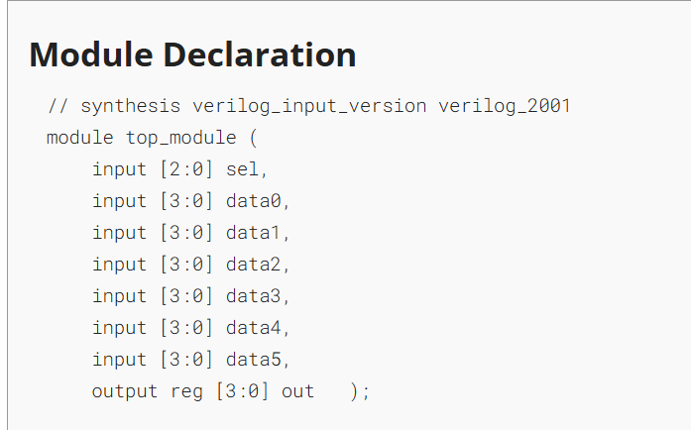

Solution:
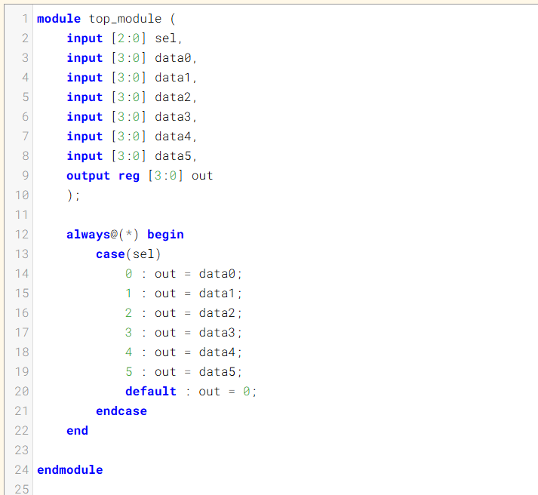

Code:
module top_module (
input [2:0] sel,
input [3:0] data0,
input [3:0] data1,
input [3:0] data2,
input [3:0] data3,
input [3:0] data4,
input [3:0] data5,
output reg [3:0] out
);

always@(*) begin
case(sel)
0 : out = data0;
1 : out = data1;
2 : out = data2;
3 : out = data3;
4 : out = data4;
5 : out = data5;
default : out = 0;
endcase
end

endmodule

Timing Diagram:
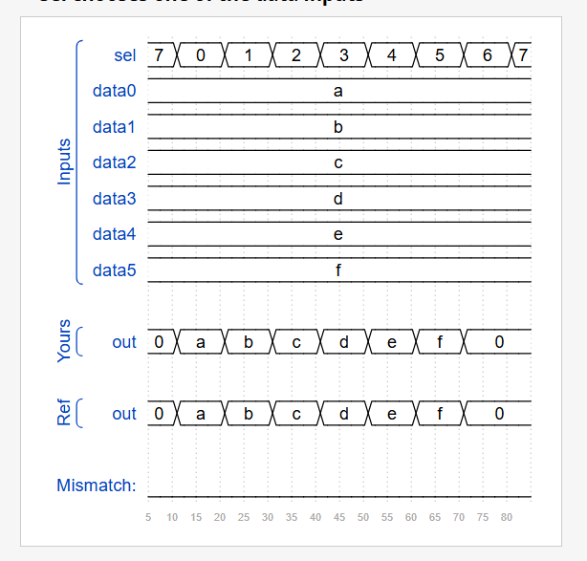

DAY:32 Always_case2
Problem Statement:
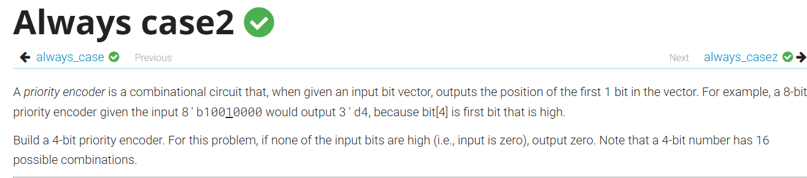
Module Declaration:
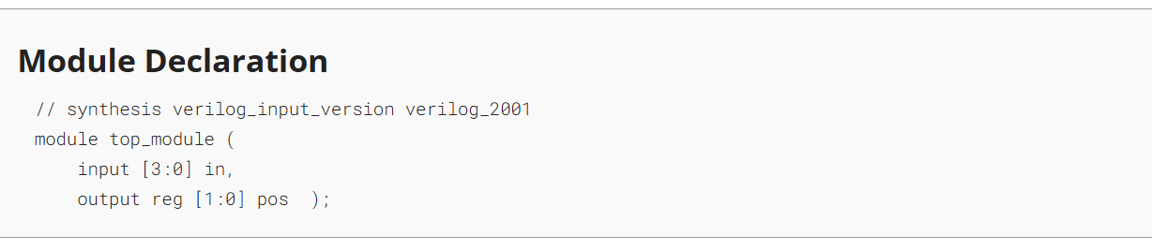
Solution:
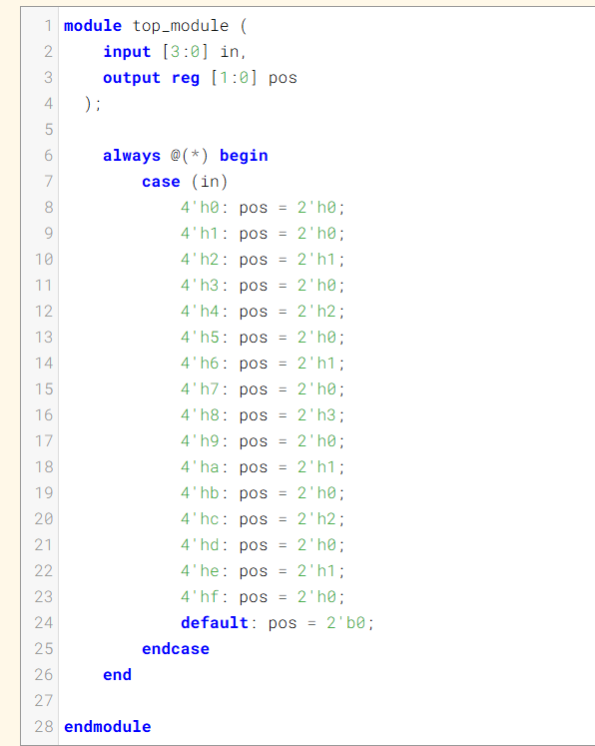
Code:
module top_module (
input [3:0] in,
output reg [1:0] pos
);

always @(*) begin
case (in)
4'h0: pos = 2'h0;
4'h1: pos = 2'h0;
4'h2: pos = 2'h1;
4'h3: pos = 2'h0;
4'h4: pos = 2'h2;
4'h5: pos = 2'h0;
4'h6: pos = 2'h1;
4'h7: pos = 2'h0;
4'h8: pos = 2'h3;
4'h9: pos = 2'h0;
4'ha: pos = 2'h1;
4'hb: pos = 2'h0;
4'hc: pos = 2'h2;
4'hd: pos = 2'h0;
4'he: pos = 2'h1;
4'hf: pos = 2'h0;
default: pos = 2'b0;
endcase
end

endmodule
Timing Diagram:
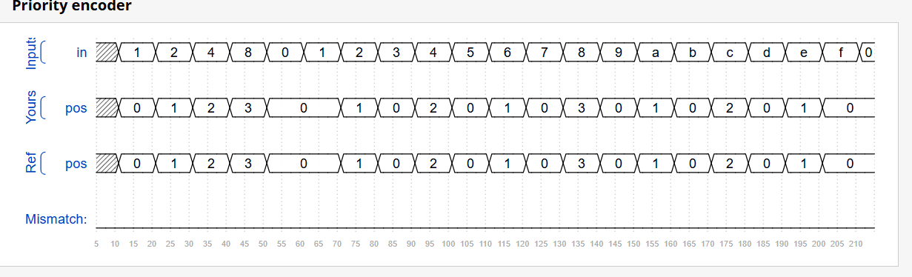

DAY:33 Always_casez
Problem Statement:
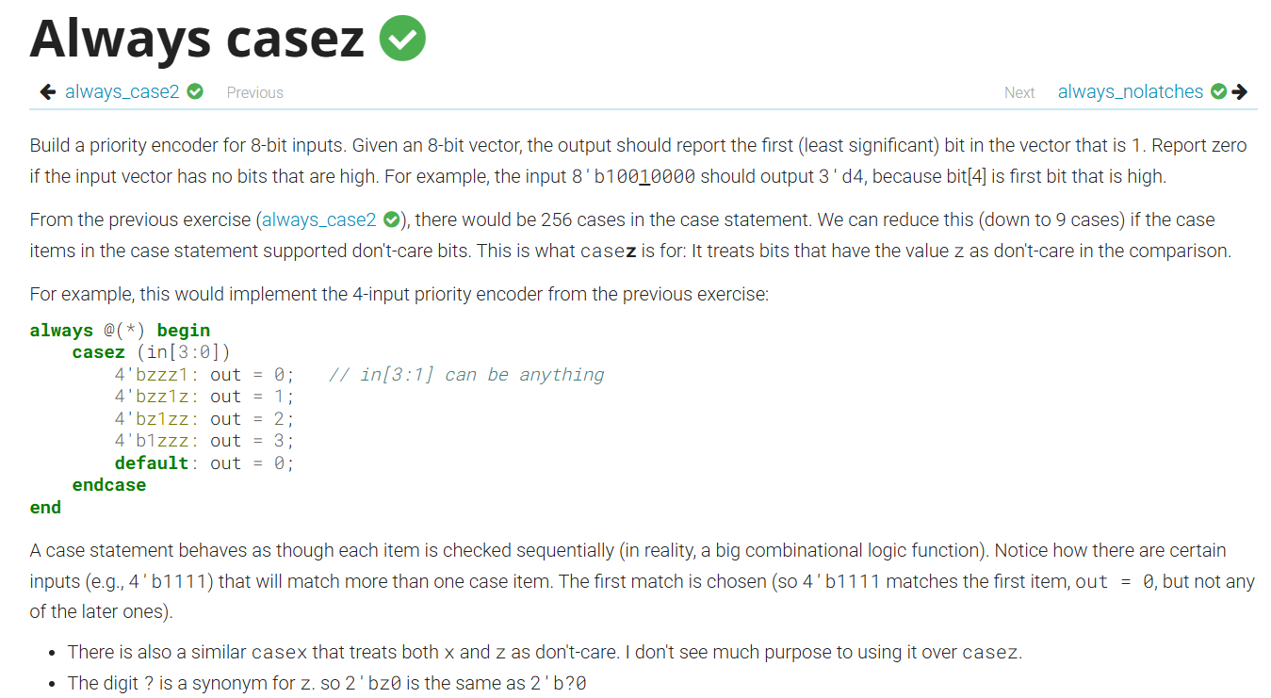

Module Declaration:
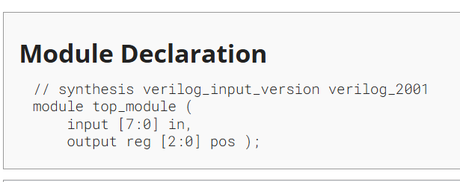

Solution:
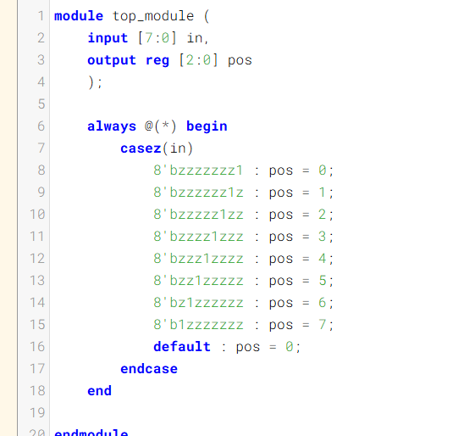
Code:
module top_module (
input [7:0] in,
output reg [2:0] pos
);

always @(*) begin
casez(in)
8'bzzzzzzz1 : pos = 0;
8'bzzzzzz1z : pos = 1;
8'bzzzzz1zz : pos = 2;
8'bzzzz1zzz : pos = 3;
8'bzzz1zzzz : pos = 4;
8'bzz1zzzzz : pos = 5;
8'bz1zzzzzz : pos = 6;
8'b1zzzzzzz : pos = 7;
default : pos = 0;
endcase
end

endmodule
Timing Diagram:

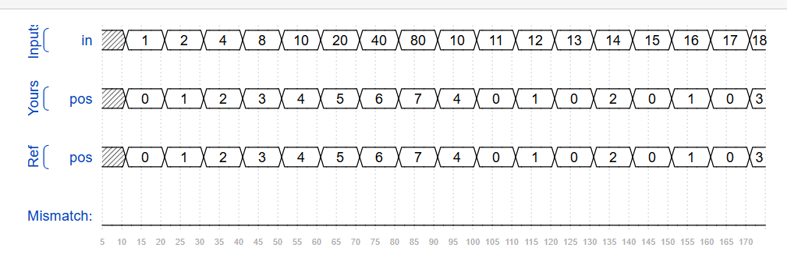

DAY:34 Always_nolatches
Problem Statement:
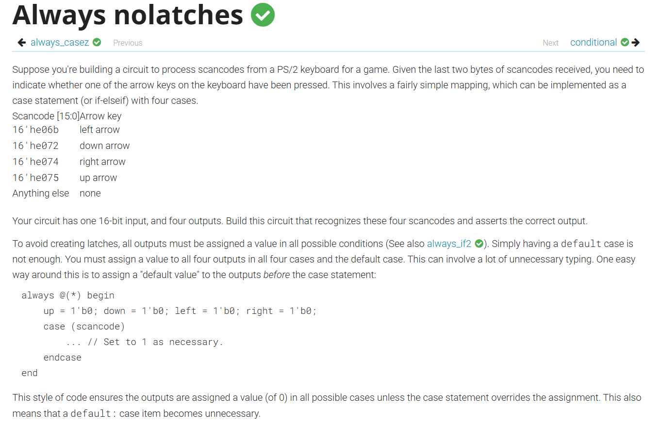
Module Declaration:
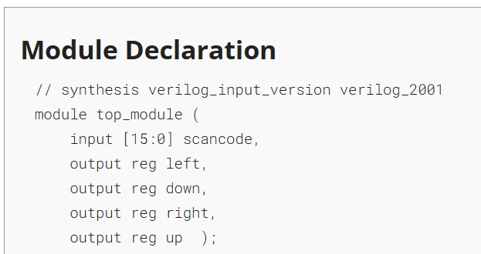
Solution:
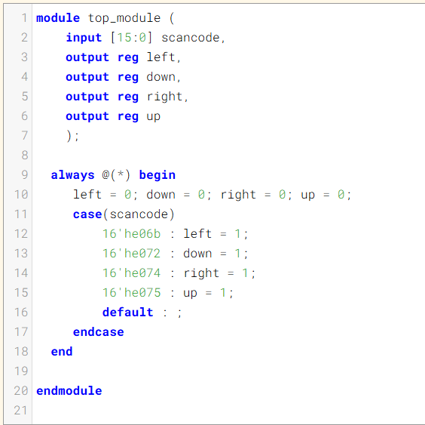
Code:
module top_module (
input [15:0] scancode,
output reg left,
output reg down,
output reg right,
output reg up );
always @(*) begin
left = 0; down = 0; right = 0; up = 0;
case(scancode)
16'he06b : left = 1;
16'he072 : down = 1;
16'he074 : right = 1;
16'he075 : up = 1;
default : ;
endcase
end
endmodule

Timing Diagram:
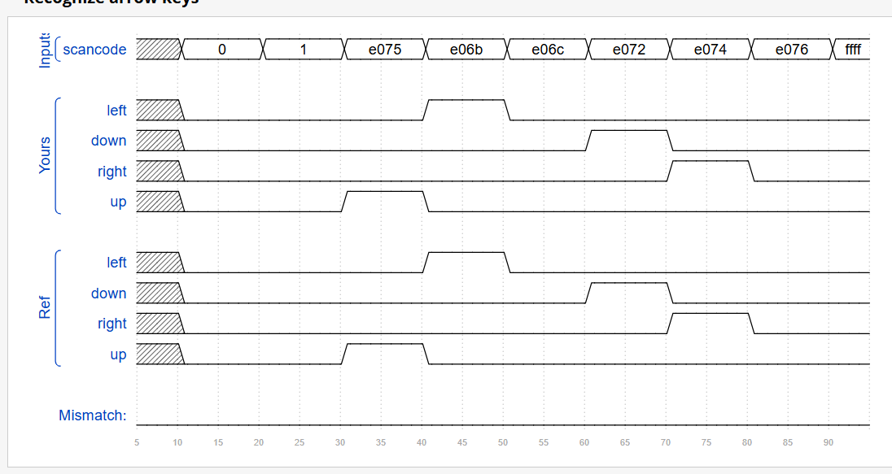

DAY:35 Conditional
Problem Statement:
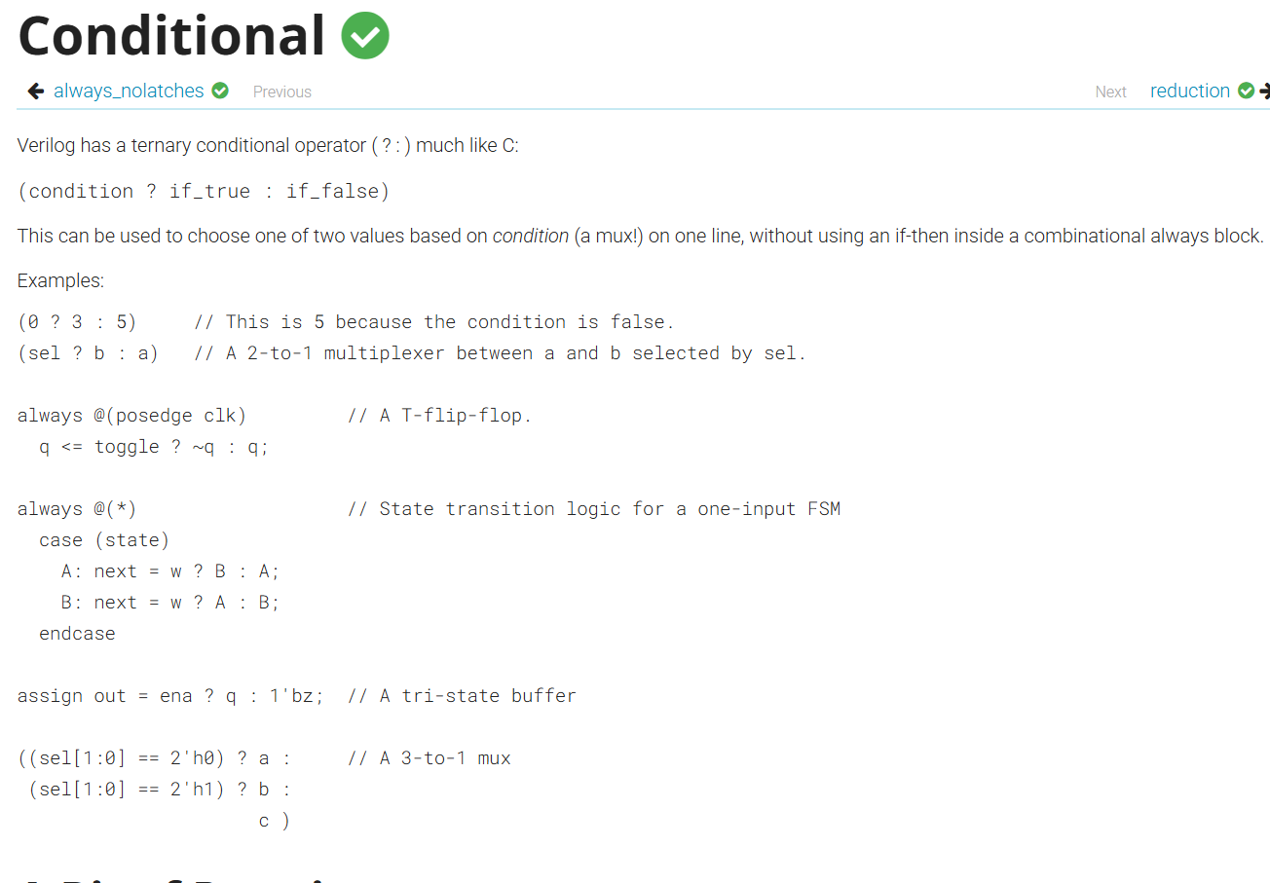
Module Declaration:
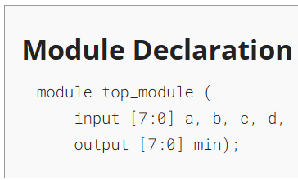

Solution:
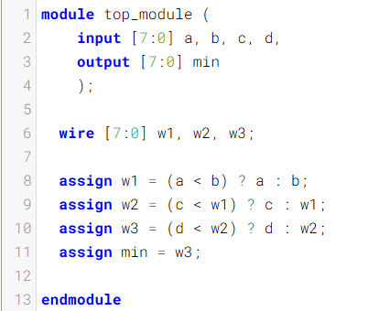
Code:
module top_module (
input [7:0] a, b, c, d,
output [7:0] min );
wire [7:0] w1, w2, w3;
assign w1 = (a < b) ? a : b;
assign w2 = (c < w1) ? c : w1;
assign w3 = (d < w2) ? d : w2;
assign min = w3;

endmodule
Timing Diagram:
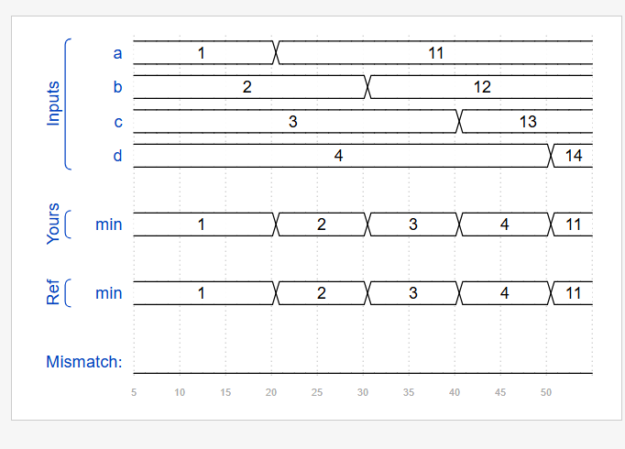
DAY:36 Reduction
Problem Statement:
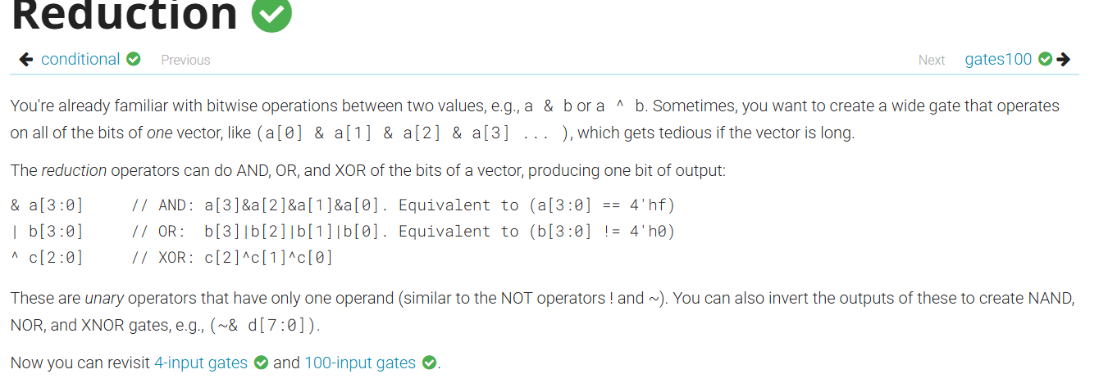

Module Declaration:
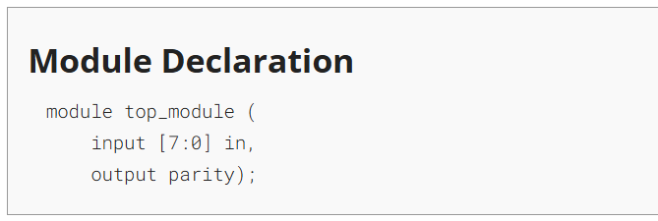

Solution:
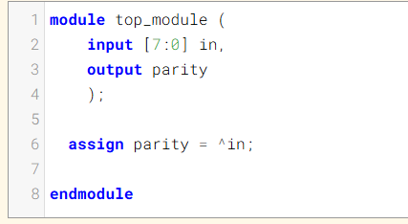
Code:
module top_module (
input [7:0] in,
output parity );
assign parity = ^in;

endmodule
DAY:37 Gates100
Problem Statement:
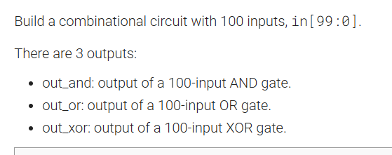

Module Declaration:
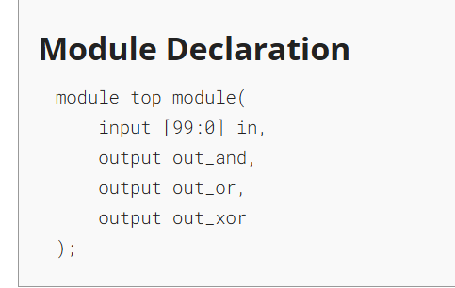

Solution:
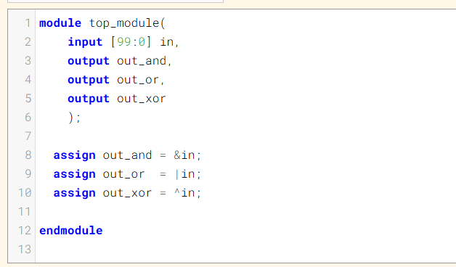
Code:
module top_module(
input [99:0] in,
output out_and,
output out_or,
output out_xor
);
assign out_and = &in;
assign out_or = |in;
assign out_xor = ^in;
endmodule
Timing Diagram:
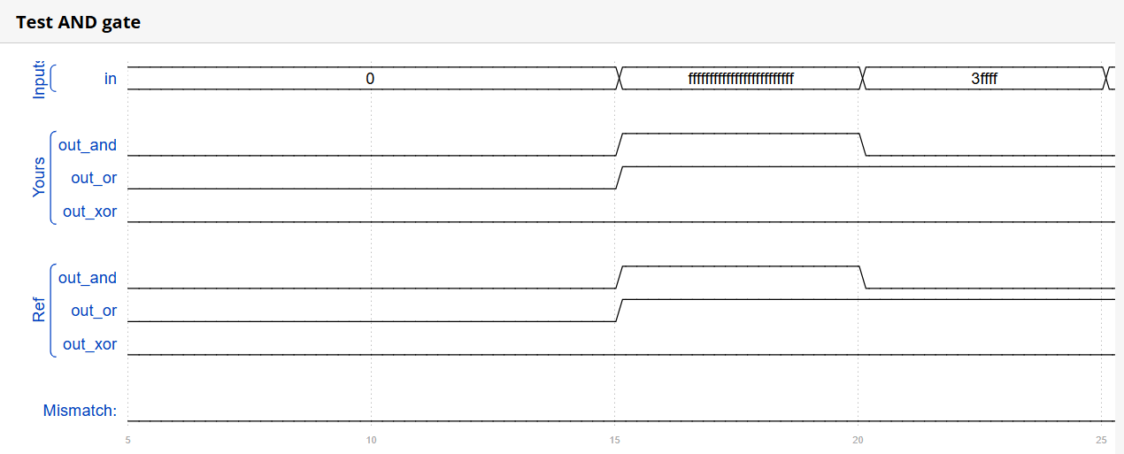
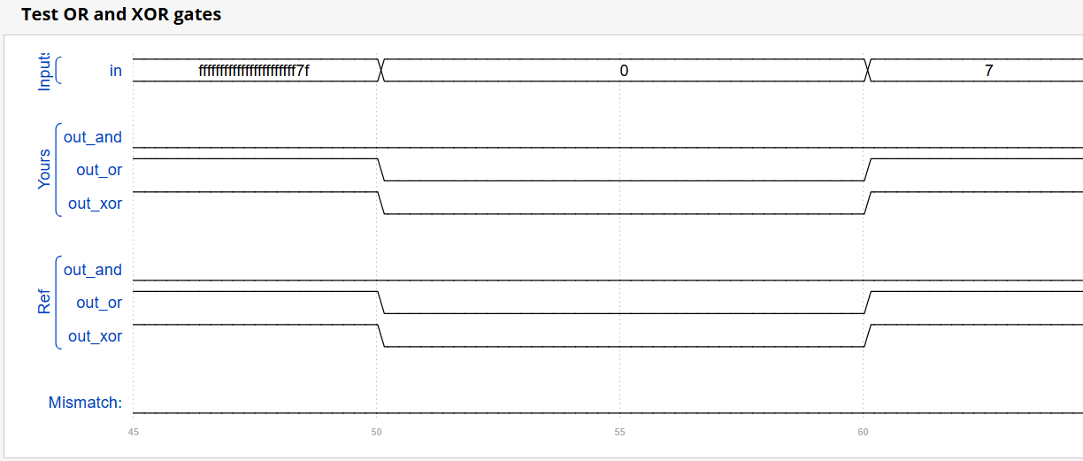

DAY:38 vector100r
Problem Statement:
Given a 100-bit input vector [99:0], reverse its bit ordering.
Module Declaration:
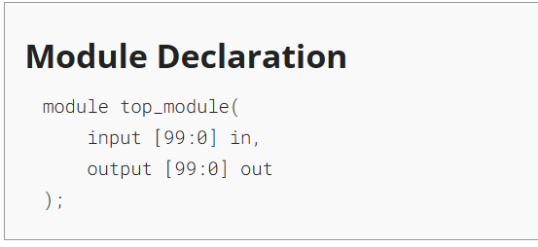
Solution:
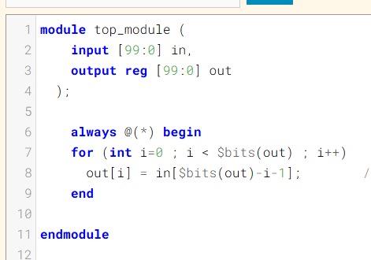
Code:
module top_module (
input [99:0] in,
output reg [99:0] out
);
always @(*) begin
for (int i=0 ; i < $bits(out) ; i++)
out[i] = in[$bits(out)-i-1];
end
endmodule
DAY:39 popcount255
Problem Statement:
A "population count" circuit counts the number of '1's in an input vector. Build a population count circuit for a 255-bit input vector.
Module Declaration:
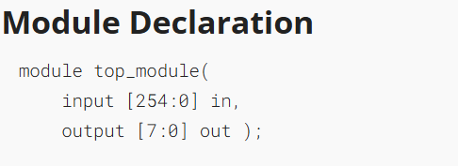
Solution:
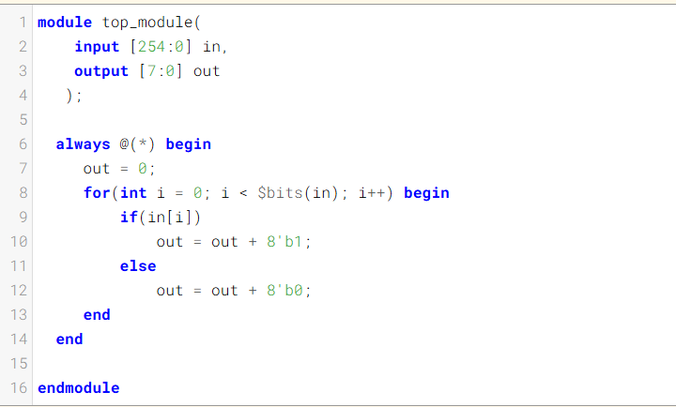
Code:
module top_module(
input [254:0] in,
output [7:0] out
);
always @(*) begin
out = 0;
for(int i = 0; i < $bits(in); i++) begin
if(in[i])
out = out + 8'b1;
else
out = out + 8'b0;
end
end

endmodule
Timing Diagram:
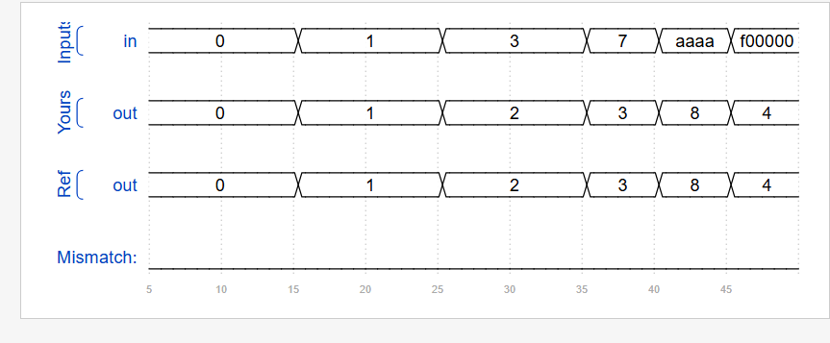

DAY:40 Adder100i
Problem Statement:

Module Declaration:
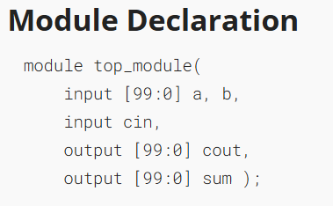

Solution:
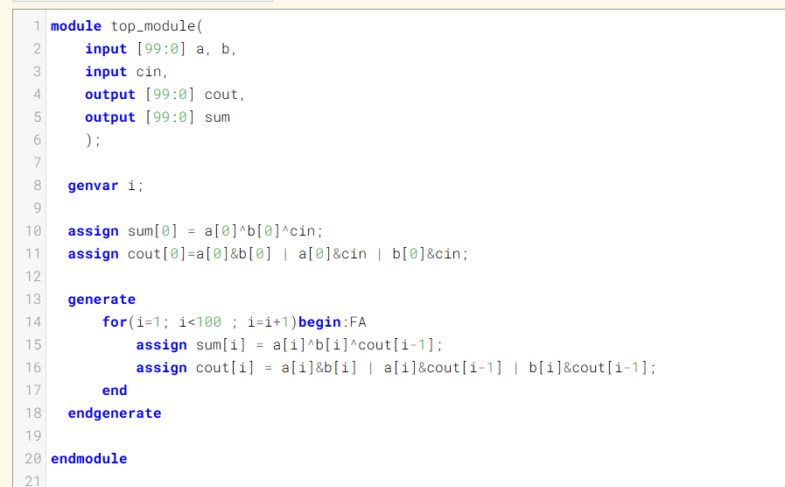

Code:
module top_module(
input [99:0] a, b,
input cin,
output [99:0] cout,
output [99:0] sum
);

genvar i;

assign sum[0] = a[0]^b[0]^cin;
assign cout[0]=a[0]&b[0] | a[0]&cin | b[0]&cin;
generate
for(i=1; i<100 ; i=i+1)begin:FA
assign sum[i] = a[i]^b[i]^cout[i-1];
assign cout[i] = a[i]&b[i] | a[i]&cout[i-1] | b[i]&cout[i-1];
end
endgenerate

endmodule



